# Lecture Notes

## Supervised Learning

### Lesson 1: Decision Trees

### Lesson 2: Regression & Classification

### Lesson 3: Neural Networks

### Lesson 4: Instance Based Learning

### Lesson 5: Ensemble – Bagging & Boosting

### Lesson 6: Kernel Methods - SVMs

### Lesson 7: Computational Learning Theory

### Lesson 8: VC Dimensions

### Lesson 9: Bayesian Learning

### Lesson 10: Bayesian Inference

## Unsupervised Learning

### Lesson 1: Random Optimization

### Lesson 2: Clustering

Unsupervised learning

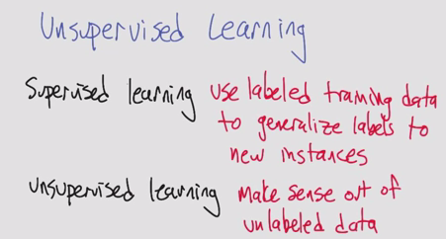

* One of the classic unsupervised learning problems is the Clustering Problem
  + It doesn’t have to be an actual distance, just has to be a similarity (like in kNN)

Basic clustering problem

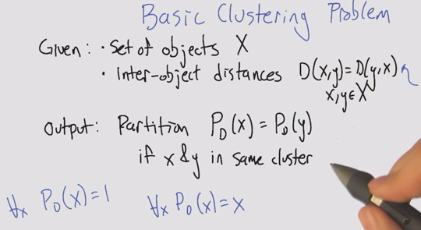

* + Trivial clusters: we can all be humans (one big cluster); we can all be ourselves (one cluster per instance)

Algorithm 1: Single Linkage Clustering (SLC)

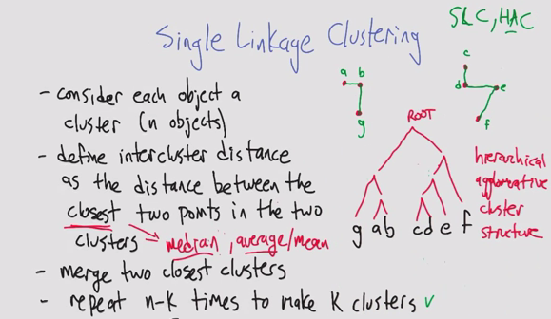

* SLC: single linkage clustering
* HAC: hierarchical agglomerative cluster

Running Time of SLC

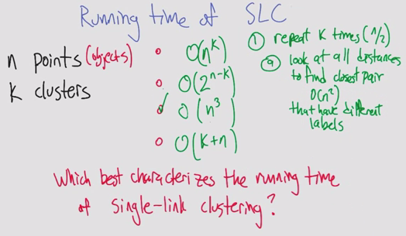

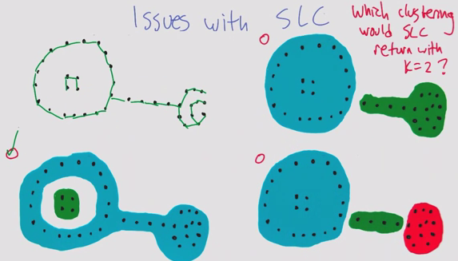

Algorithm 2: k-means Clustering

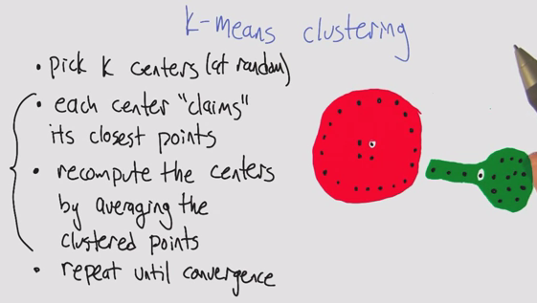

k-means Euclidean space (Part 1,2). Error does not increase, and breaks ties

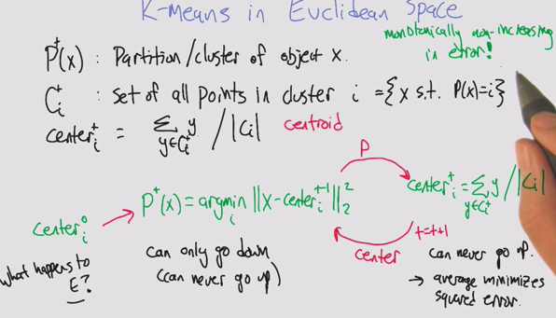

K-means as optimization. Errors as scores. Like hill climbing.

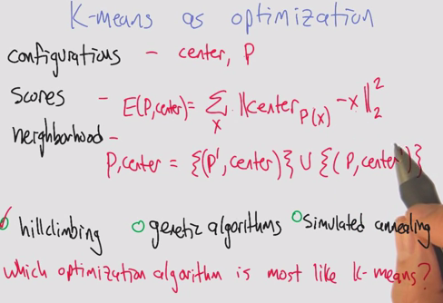

* Monotonically non-increasing in error converges because there are a finite number of objects, even though it’s an infinite space
* You may have a point that goes between two partitions equally, so you need a way of breaking ties
  + Tendency to go to smaller cluster

Properties of k-means clustering

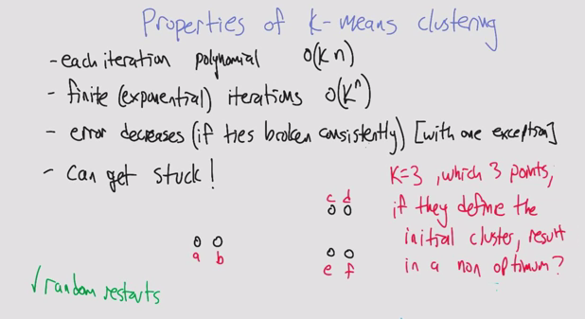

* How do you avoid non-optimum clustering?
  + Random restarts
  + Choosing centers that are furthest apart

Soft clustering

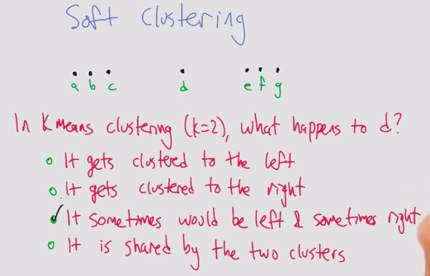

* Example of how the initial centers affects the end convergence
  + D would end up on the right if you start with a/b center, left if you start with f/g and would depend on tie breaking if a/g

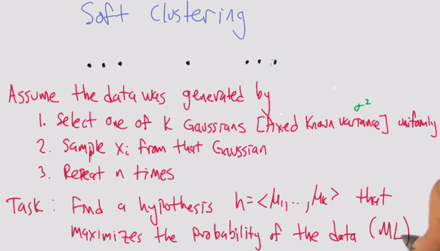

* Thinking “bayesianly”, given the data we’re going find what the clusters would have been to generate the data

Maximum likelihood Gaussian

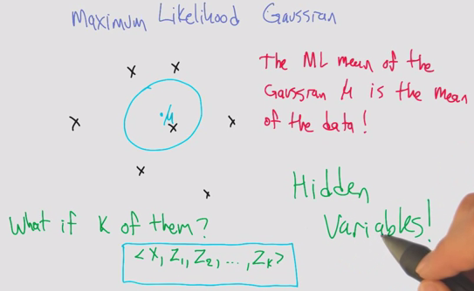

* Using hidden variables to break up the problem in a convenient way
* X lies in one of the clusters Zn (a bunch of 0s and a 1)

Algorithm 3: Expectation maximization

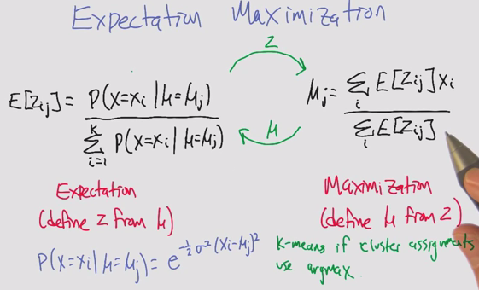

* Similar to k-means at an algorithmic level
* Tick tock between expectation (E)and maximization (miu)
* Maximization allows for partials / weighted average.
* E: Soft clustering, given the miu and x, we can compute how likely it is in z
* M: computing mean, if that is the cluster, we can take the average of the xi within each cluster j, what’s the likelihood it came from cluster j
* This can be kmeans if all the probabilities were 1s and 0s, so the maximization step would just be the means (since it’s just normalizing)
  + Then you have to push the probabilities of being in the clusters 1 and 0s
  + Kmeans if cluster assignments use argmax (1 and 0)

EM Example

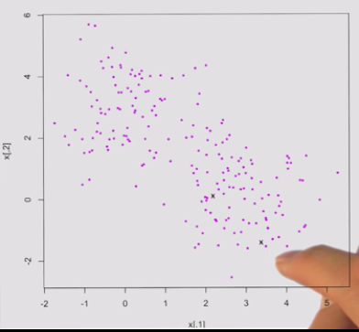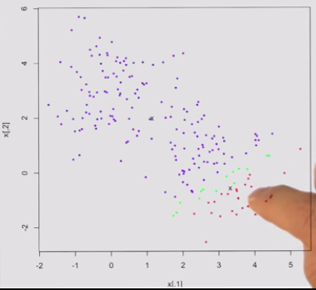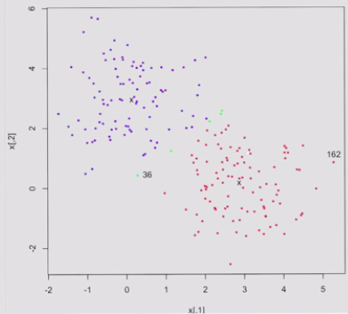

* Pick 2 centers, select 2 points randomly
* Run iteration of EM
  + Expectation
  + Move centers
  + Label the band in the middle that aren’t deeply one or the other
* Not forced to make a decision

Properties of EM

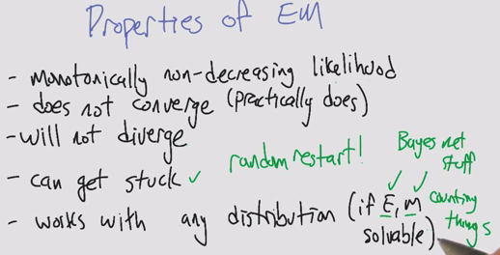

* Sometimes E or M can be hard

Clustering Properties

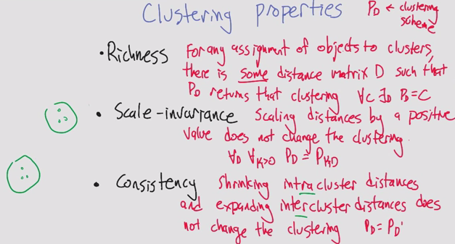

* Consistency is harder to visualize
  + If you make the objects in a cluster more similar, and the other ones more dissimilar, the clusters do not change

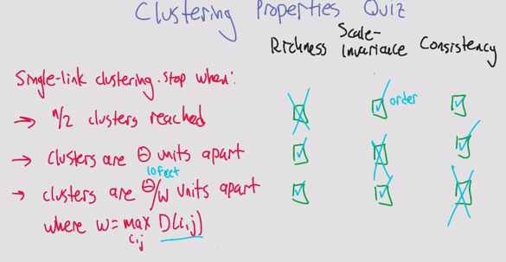

Impossibility Theorem

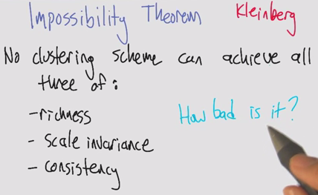

* Defined by Kleinberg
* All 3 are mutually contradictory

Summary

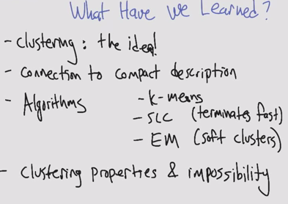

### Lesson 3: Feature Selection

Introduction

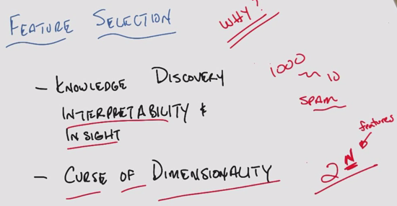

* Feature selection tends to be ignored in the realm of ML

Algorithms

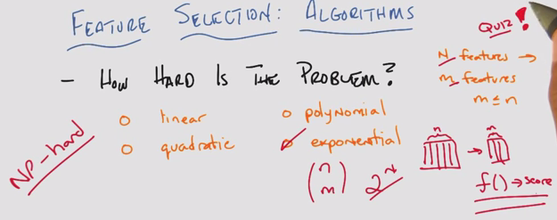

Algorithms: Filtering and wrapping

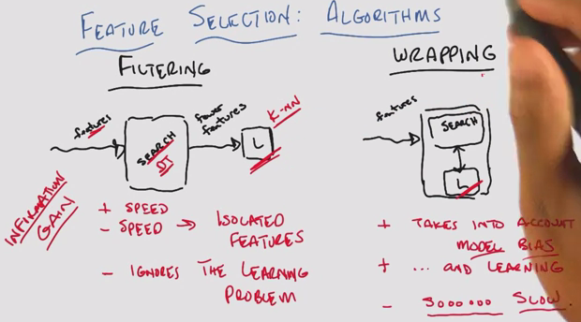

* Tradeoffs: speed, feedback
* Imagine filtering is like decision trees
* Wrapping requires cross validation, tons of computations

Methods for Filtering/Wrapping

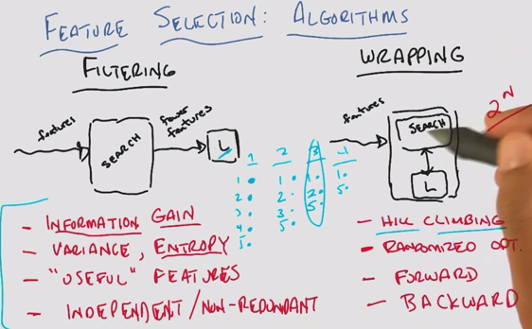

* Forward/backward search. Forward is like hill climbing if you do it one at a time
* Forward is like building the team one player at a time, backward is like removing one a time

Zero training error

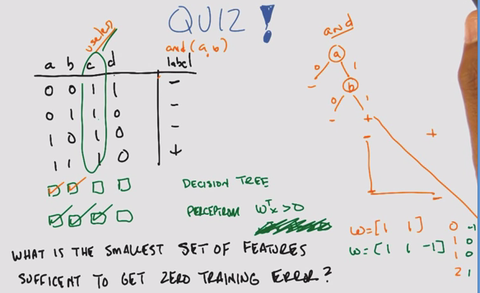

* Features a, b, c, d. Instances n=4
* DT: Build a decision tree
  + Split on A to see if A gives a positive label
  + Split on B
  + If A AND B are true, output true
  + C is *useless* because it doesn’t have info
  + D does not help with +
* Perceptron: Write 2D plane. Without intercept, it’s a origin limited perceptron
  + We know A and B are useful from DT
  + Plot A and B on a perceptron graph
    - w [1 1] outputs values of 0, 1, 1, 2
    - But wtx > 0 applies to 3 instances
    - Use a 3rd feature as the intercept
      * B, bias unit
  + Try A and B with C as bias unit
    - w [1 1 -1] outputs -1, 0, 0, 1
    - wtx > 0 applies to just the one +
* C is not useful in DT, but it is for the perceptron.
* You can use information gain, entropy, variance to determine what’s relevant

Relevance

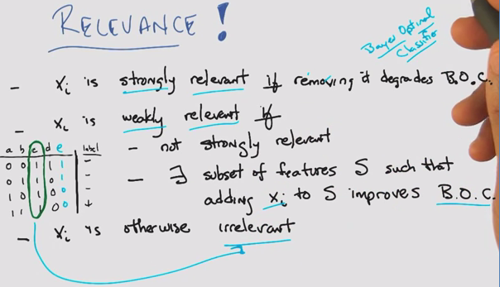

* A/B are strongly relevant, C is irrelevant
* With E added
  + A is not E, so they are weakly relevant
  + B is strongly relevant, C is irrelevant
* BOC: Bayes optimal classifier, as discussed earlier in SL (wt avg of all the hypotheses based on the probability they correctly represent the data)
* C is irrelevant, but it was useful in perceptron case

Usefulness

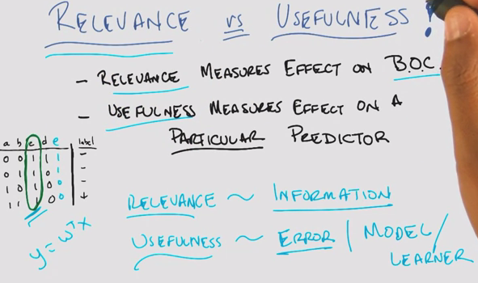

* Look at the cluster changes based on relevance and usefulness

Summary

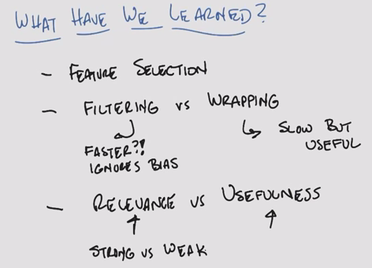

### Lesson 4: Feature Transformation

Intro

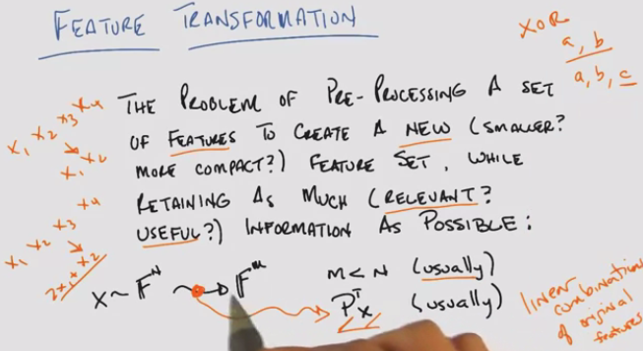

* How is this different from feature selection?
  + Think of this as a subset of feature selection
  + Transformation into a smaller subset, such that you have linear combinations of original features
  + Don’t necessarily need to go into fewer dimensions
    - We’ve done this before in Perceptrons, Kernels, XOR

Why Feature transformation?

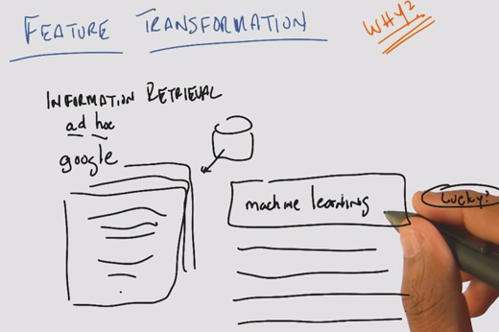

* Example: ad hoc because you don’t know what the retrieval is going to be, like Google

What are our features?

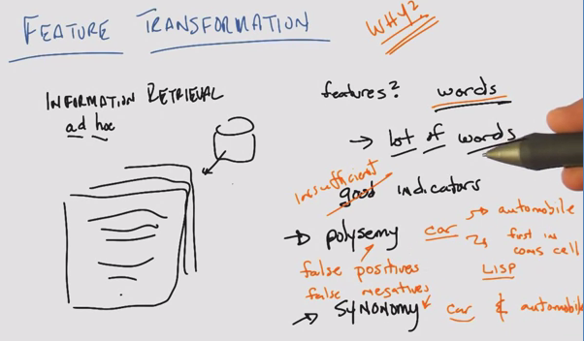

* A lot of words >>> curse of dimensionality
* Words like Tesla
* Polysemy: word w multiple meanings. False pos
* Synonymy: same meaning expressed in different words. False neg

Principal Components Analysis

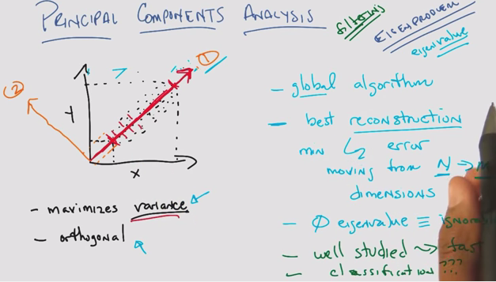

* Projecting 2D data onto x or y axis is an example of feature ***selection***
* Feature ***transformation***: projecting onto a diagonal plane maximizes variance on 1 feature
* PCA
  + 1. Maximizes variance
  + 2. Mutually Orthogonal
* Like filtering
* Reconstruction: You can reconstruct all the original data with the new axes
* Tend to subtract the mean from the data to normalize to the origin, to look for correlation
* Eigenvalue properties

Independent Components Analysis

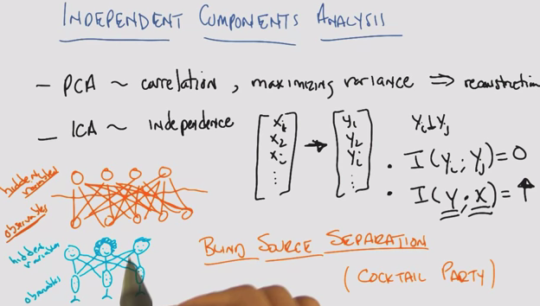

* PCA ~ correlation, maximizing variance => reconstruction
* ICA ~ maximizing mutual independence
  + Linear transformation such that each new feature is statistically independent from one another yi | yj
  + Mutual information = I (yi ; yj) = 0
  + Mutual information of the new features and the original features is max (reconstructs well) = I (y . x) high
* Blind source separations (cocktail party)
  + Trying to listen to one person at a party, while cutting out the noise of other conversations
  + Online Demo: <http://research.ics.aalto.fi/ica/cocktail/cocktail_en.cgi>

Matrix

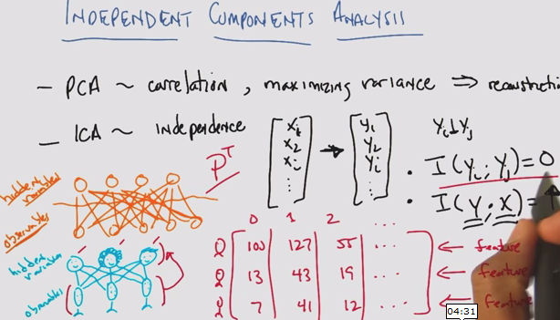

PCA vs ICA

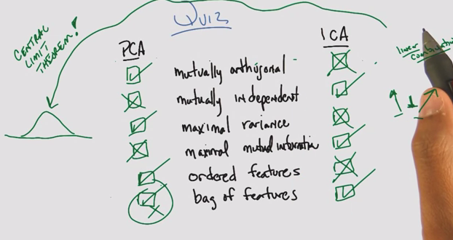

* PCA tends to find things that are uncorrelated, not same as statistically independent
  + Coincidence: When all of the data is Gaussian, it is possible for PCA to both represent data that is mutually orthogonal  ***and*** mutually independent
* ICA assuming highly non-normal
  + What if the independent variables are summed together into a linear combination? By central limit theorem, you will get a Gaussian
* ICA: Mutually independent projections, mutual information between old and new
* PCA/ICA fundamental assumptions are different, both trying to represent the data
* Bag of features: Order doesn’t matter for ICA

PCA vs. ICA cont’d

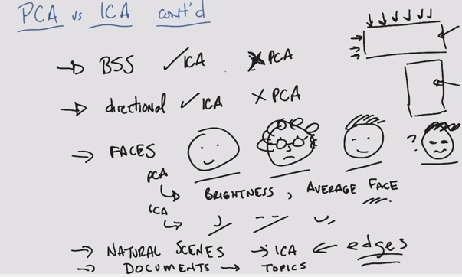

* ICA was designed for BSS (blind source separation problem), whereas PCA does a terrible job
* ICA is directional, whereas PCA finds the same answer whether you give one dimension of a matrix or another
* ICA tends to pull out edges from images, therefore we can use faster algorithms that find edges as a substitute
* Average face = “eigenface”
* PCA tends to find global, ICA tends to find parts of

Alternatives

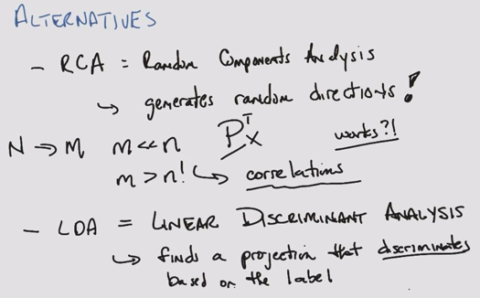

* RCA: Random components analysis
  + Cheap, easy, fast
  + Simple yet they manage to work
* M tends to be bigger than m in PCA
* Time: ICA>PCA>RCA
  + Feel like filtering, optimize but don’t care about the final labels
* LDA is like supervised learning
  + Transformations into clusters based on their label

Summary

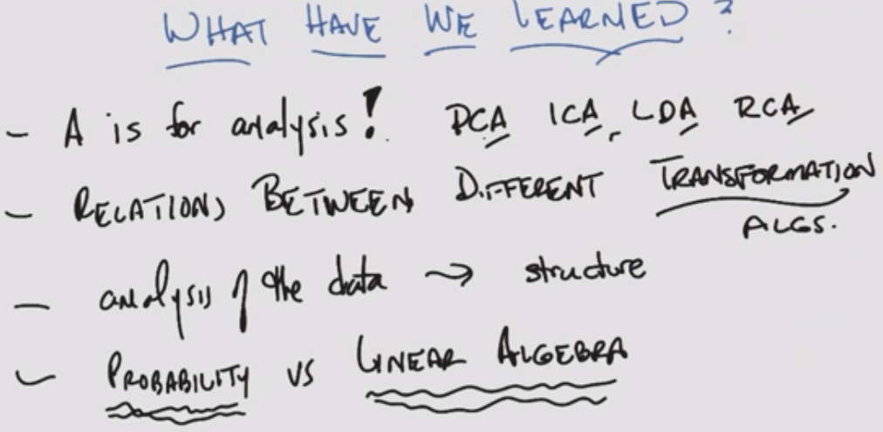

* ICA: probability. Hard to find, more expensive, but when it does it produces a satisfying answer
* PCA: linear algebra. Well understood, not exactly what you want

### Lesson 5: Information Theory

Intro

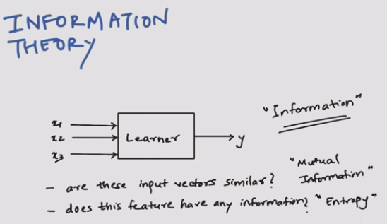

* Mutual information vs. entropy

History

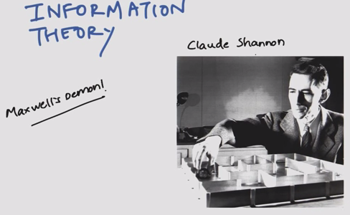

* Claude Shannon and messages
* Maxwell’s demon

Message example

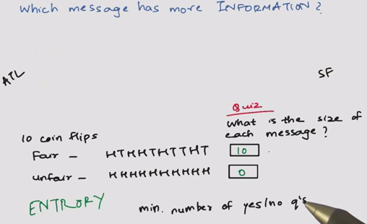

New message example

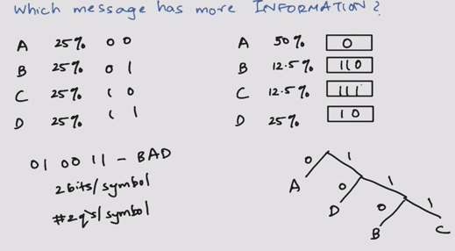

* 25% equal:
  + 2 bits per symbol
  + 2 questions per symbol
* Non-equal

Expected size of message

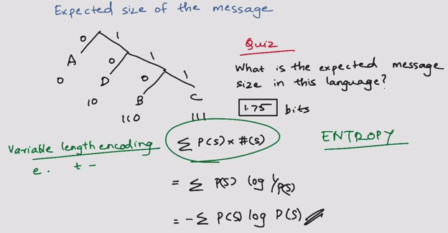

* Variable length encoding, 1.75 bits
* Entropy = #Bits = probability (symbol) * # symbols

Information between two variables

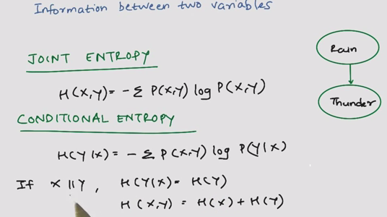

* Joint entropy
* Conditional entropy

Mutual information

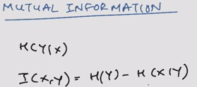

Two independent coins

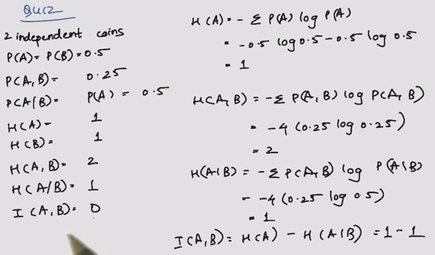

* Why n=4 for entropy?

Two dependent coins

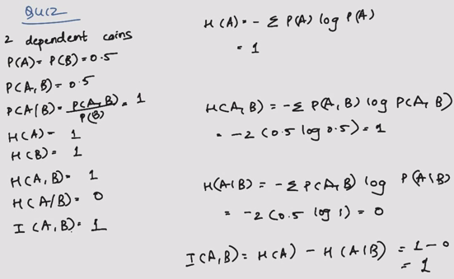

Kullback-Leibler Divergence

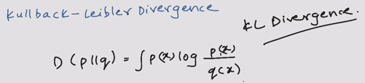

* Distance metric that does not follow triangle law
* Substitute to Least Squares

Summary

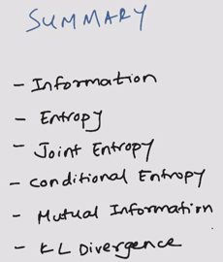

## Reinforcement Learning

### Lesson 1: Markov Decision Processes

Decision Making and Reinforcement Learning

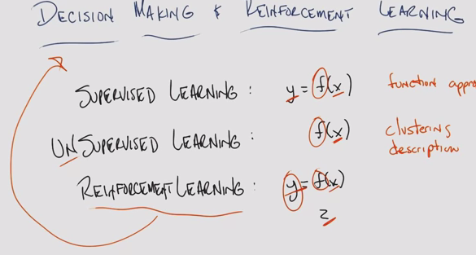

* SL: Given a set of x-y pairs, you are trying to find a function f that will map some new x to the proper y
* UL: Given some x, and trying to find f. Give a compact description of the set of x’s
* RL: Looks a lot of SL. Given a string of pairs of data to learn a function. Instead, given x-z pairs to find a function f that generates y
  + X
  + Z
  + One mechanism that is used in decision making

The World

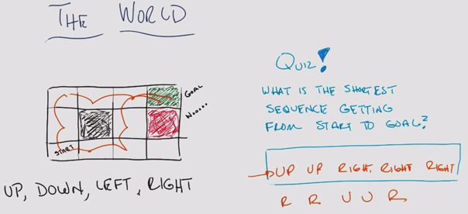

The World II

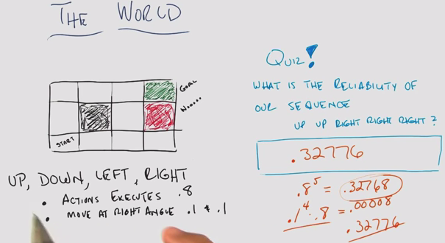

* Plan for when something “goes wrong”

Markov Decision Processes

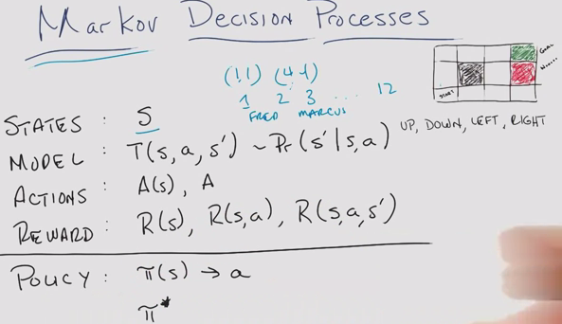

* S: State – grid location
* T: Transition
* Pr: Probability
* A: Action: Up down left right
* R: Reward

Markovian Property

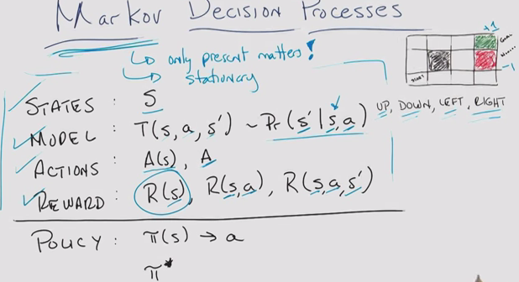

* Markovian: Only the present matters (not the past)
  + You can turn almost anything into a Markovian
* The roles, world, model are stationary
* Rewards represent domain knowledge

Rewards

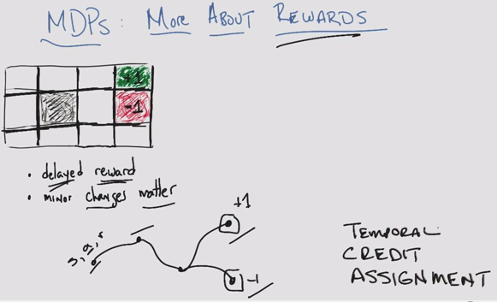

* (Temporal) credit assignment problem
  + Delayed reward, unknown at the time the action was made

Example

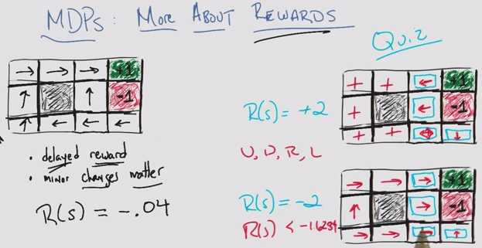

* Reward of -0.04 for all unlabelled states, encourage reaching the goal
* Like walking on hot sand trying to get to the shore
* Minor changes in your rewards matter
* Since this is Markovian, some states don’t matter
* Can be solved using expected value

Sequences of Rewards: Assumptions

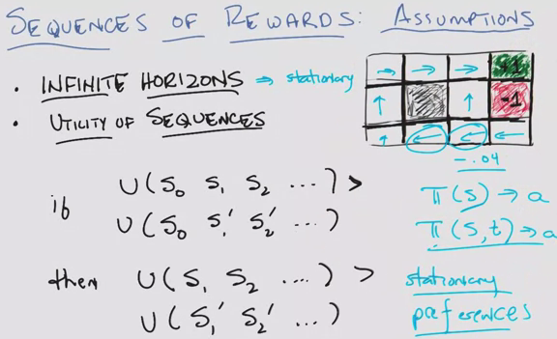

* Infinite horizons: stationary
  + GridWorld example, need to add cost of -0.04 so it ends
  + But also, we assume that the agent is allowed the number of time steps take the long route
  + But if time is limited, then the agent perhaps will take the risky shortcut
  + If you have a finite horizon
    - The policy will change from the converged policy of an infinite horizon
    - But ***also*** the policy will change in time, even for the same state
      * Policy: account for state AND time (not for this course)
* Utility sequences (prior states don’t matter)

Example

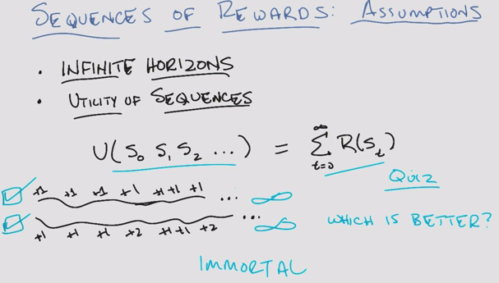

* Given this reward scheme, both approach infinity, so neither is better!

Example with different rewards:

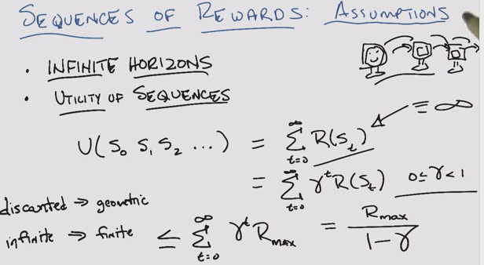

* Discounted rewards brings infinite > finite

Sequences of Rewards – Assumptions

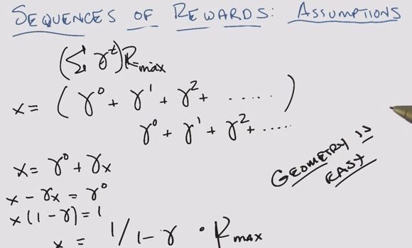

Policy

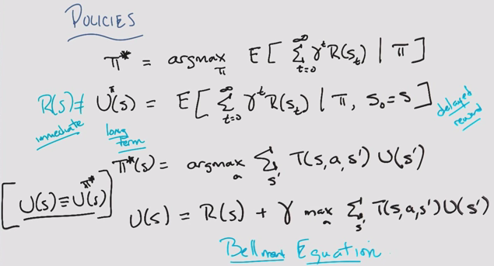

* Reward != utility
* Assume ”true” utility of the state
* Bellman Equation: the key recursive equation in MDP

Finding policies

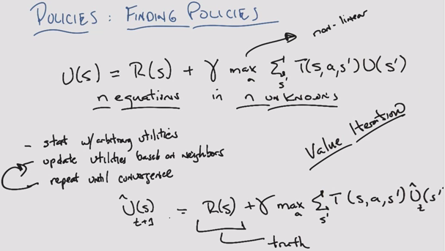

* Adding to arbitrary utility, more and more truth, and estimate is discounted. Will converge
* Value (utility) iteration

Policy quiz

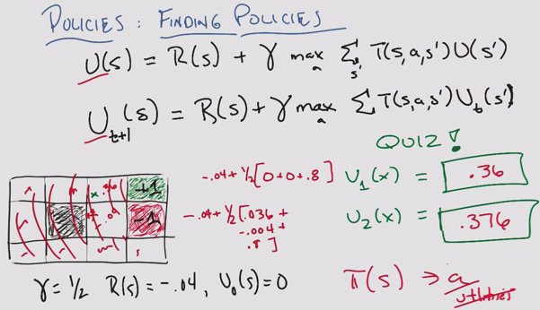

* Policy is like classification, utility like regression

Finding Policies 3

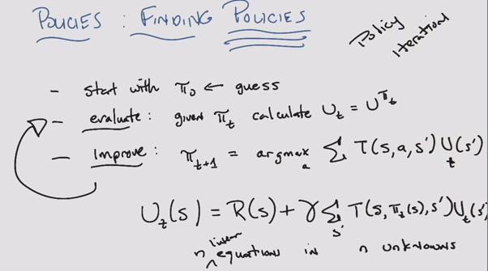

* Max was non-linear, but now this is linear
* Policy iteration (as opposed to utility iteration seen before)
* Guaranteed to converge

Summary

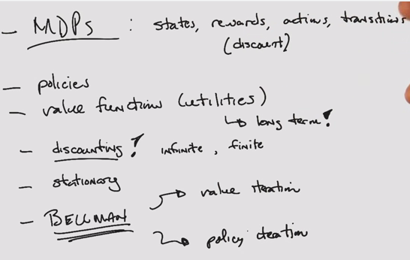

### Lesson 2: Reinforcement Learning

Application Program Interface (API)

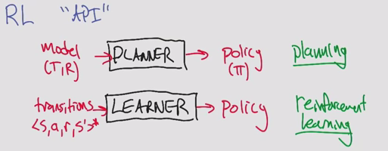

* Compute a policy vs. learn a policy

Rat Dinosaur

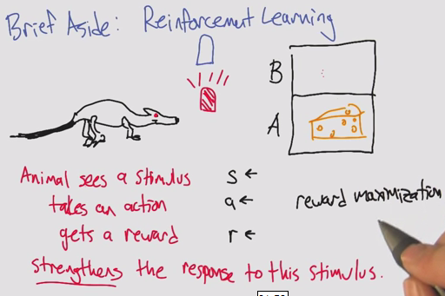

* Reinforcement learning comes from psychology
* Computer science does not focus on strengthening. Focus on reward maximization

Other APIs

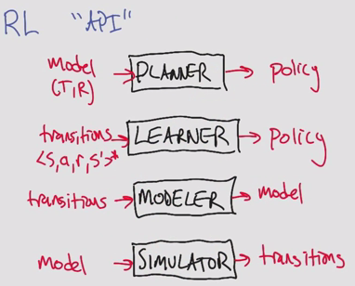

* Can be linked together to create different types of policies

Types of Reinforcement learning

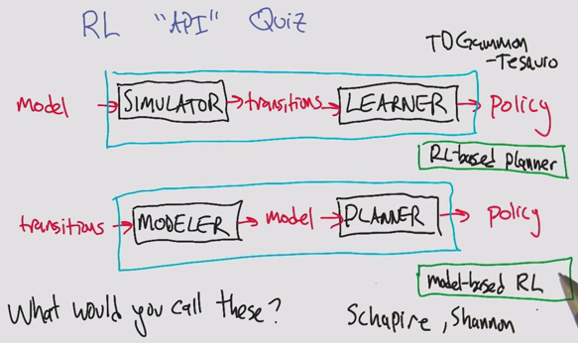

* Schapire: Boosting
* Shannon: Information Theory

3 approaches to reinforcement learning

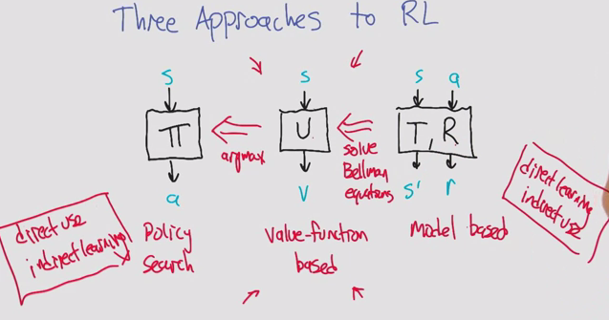

1. Policy search: Temporal credit assignment problem. Indirect learning. You learn from delayed reward.
2. Valued function based: You learn from the utility, or expected value of reward. Main focus
3. Model-based: Direct learning. Expensive Computation.

New kind of value function

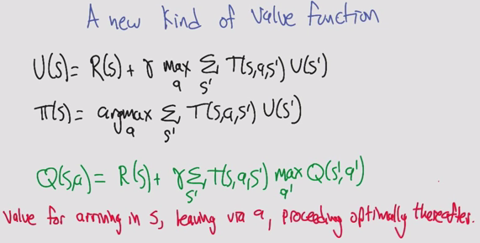

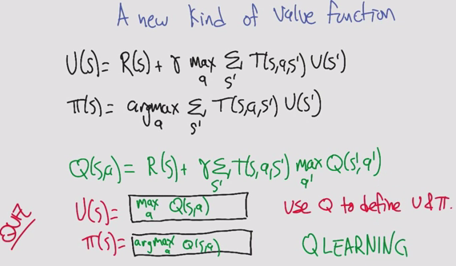

* Q: quality (other letters taken)
* Insert a utility step to compare the actions

Q-learning quiz

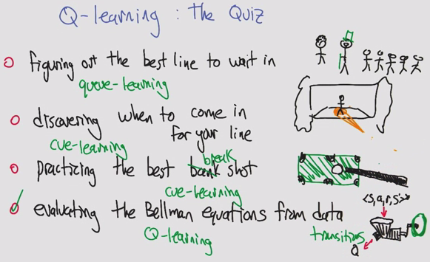

Estimating Q

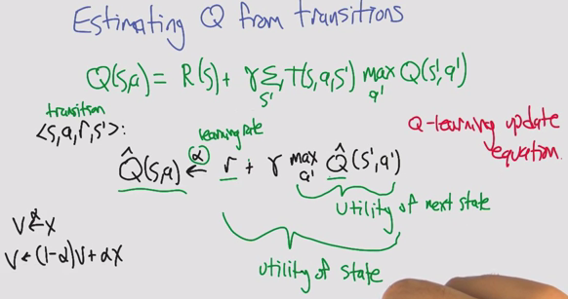

* Can’t compute Q because we don’t know R or T
* In MDPs, we do have R and T

Learning incrementally

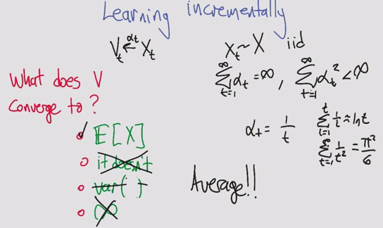

* Basal problem (pi^2/6)

Estimating Q from transitions

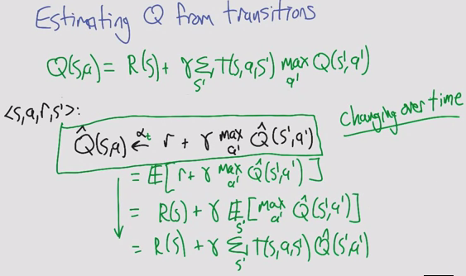

* Math tricks of expectations
* Simple update rule doesn’t actually work because Q^ is a changing target

Q learning convergence

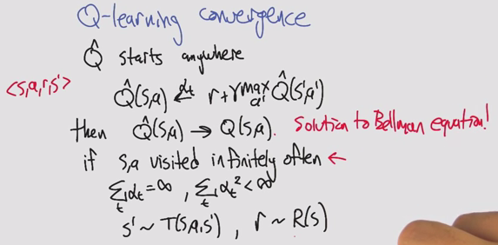

Choosing actions

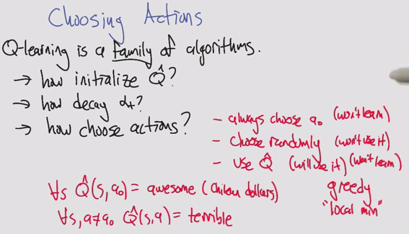

* Choosing bad actions
  + Always choose a0, ignoring q^
  + Choose randomly, wise but stupid. We know a lot, don’t do anything about it
* Greedy local min
  + Use random restarts!

Choosing actions (two)

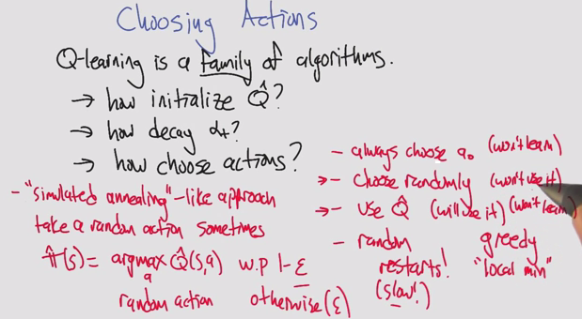

* Random optimization!
  + Simulated anneal: Random action sometimes

Greedy Exploration

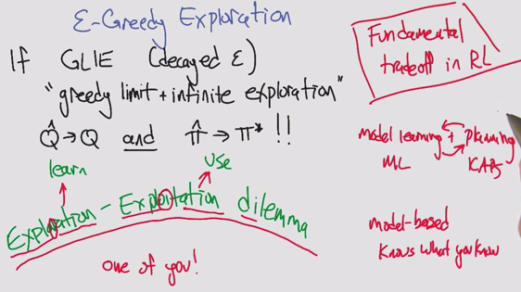

* Trade-off: Exploration & Exploitation

Summary

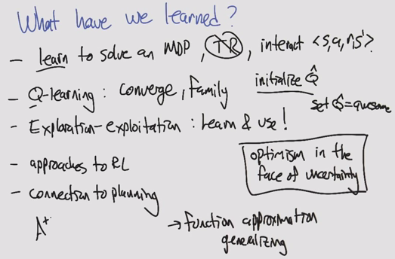

* Optimism in the face of uncertainty
* Issues of overfitting, importance of generalizing

### Lesson 3: Game Theory

Game Theory

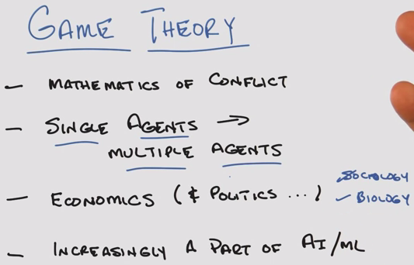

* Math of conflicts of interest
* Each agent has its own goals, intentions, interests

Quiz

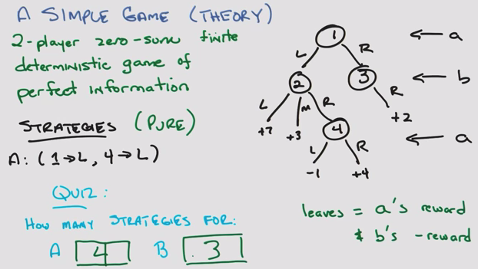

Another simple quiz

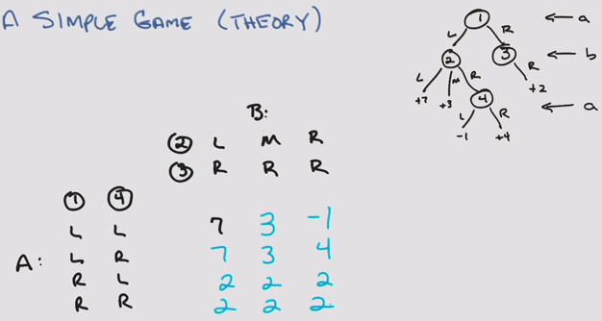

* Strategy and reward, the how is not important
* The only thing that matters is the matrix

Minimax: Value of the game

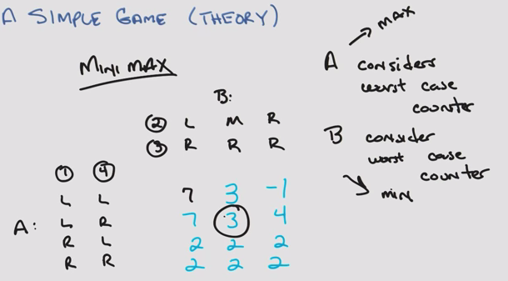

* A and B arrive at the same strategy

Fundamental result

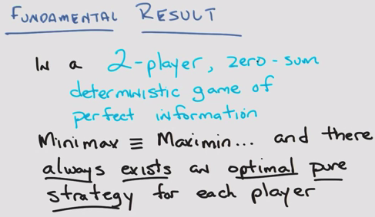

* Assume everyone is rational (trying for optimal, and assumes all other agents are maximizing)

Game tree

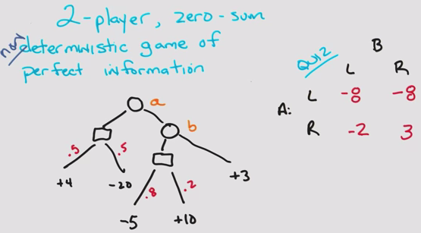

* Use the Expectation of stochastic probabilities
* Other theorem still holds! Von Neumann

Minipoker

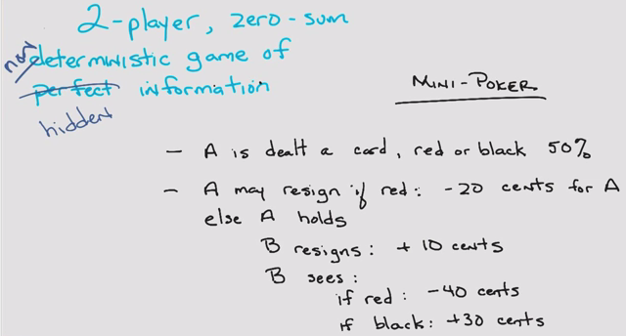

* Non-deterministic & hidden

Minipoker Tree

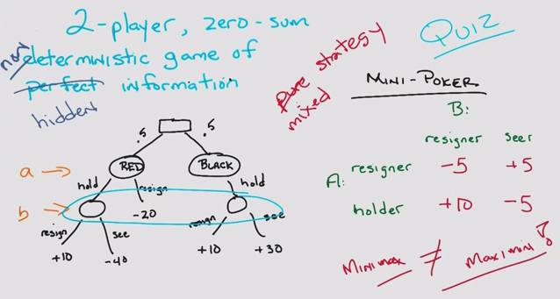

* Minimax != maximin

Quiz

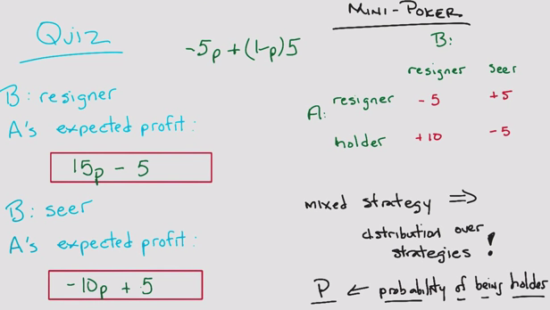

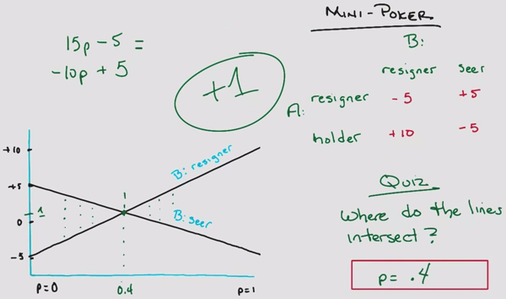

Center game

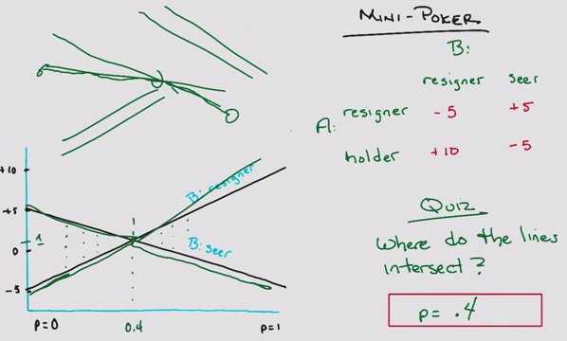

* Maximum of 3 discrete points: 2 extrema and intersection

Prisoner’s Dilemma

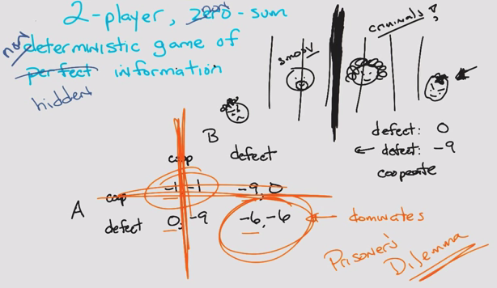

* Non-zero sum

A beautiful equilibrium

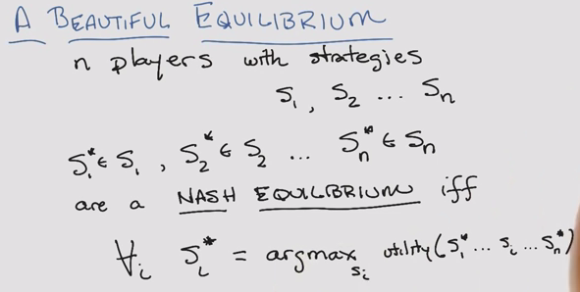

* John Nash: A Beautiful Mind

A Beautiful Equilibrium – Quiz

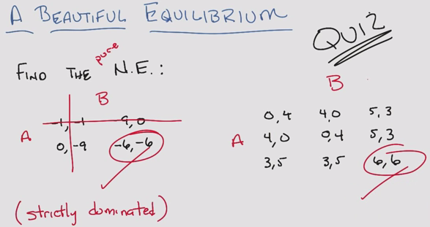

A Beautiful Equilibrium Two

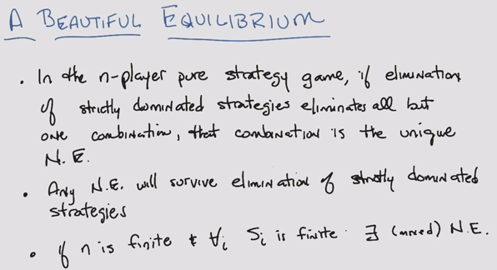

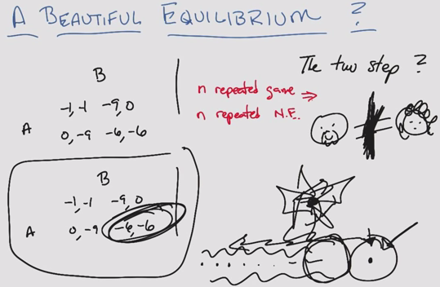

Summary

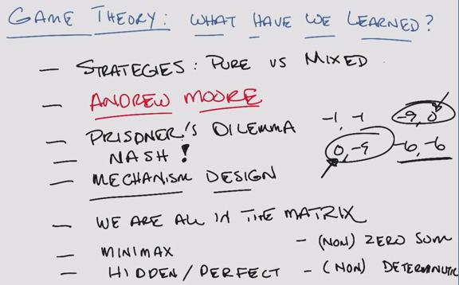

* Relaxed the constraints

### Lesson 4: Game Theory – Continued

Iterated Prisoner’s Dilemma

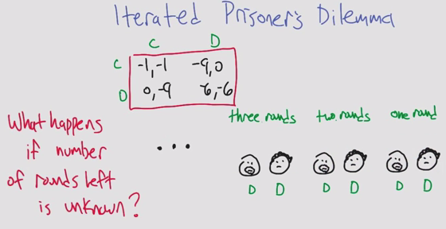

* C: cooperate
* D: defect

Uncertain End

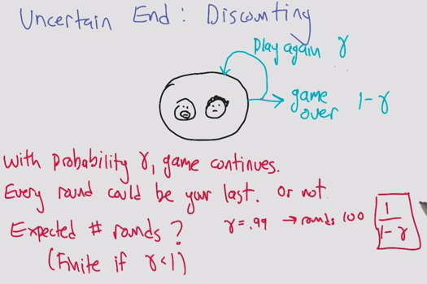

Tit for Tat

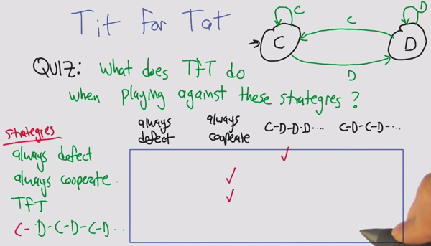

Facing Tit for Tat

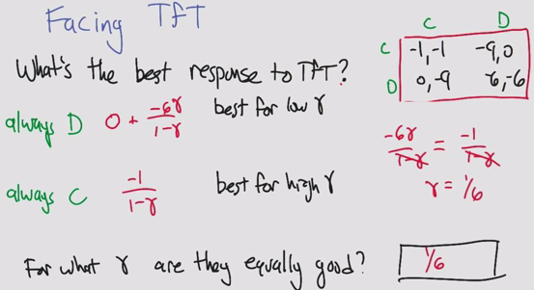

Finite State Strategy

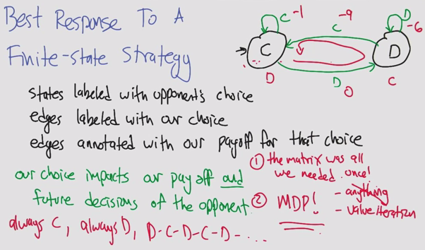

Best Responses in IPD (Iterated Prisoner’s Dilemma)

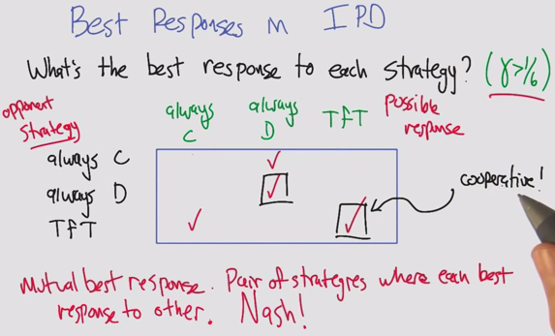

Folk Theorem

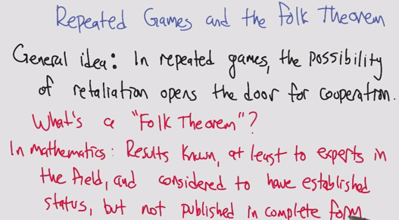

* Folk Theorem is the wrong wording in Game Theory
* In mathematics (ie. NOT in game theory): General understanding, not credited to a specific person

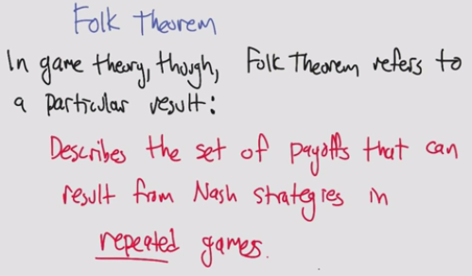

* In game theory: a set of payoffs that results from Nash strategies

Repeated Games and the Folk Theorem

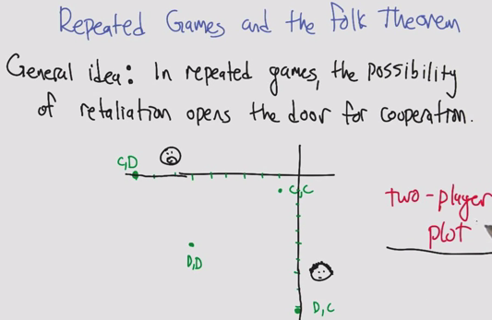

Repeated Games Quiz

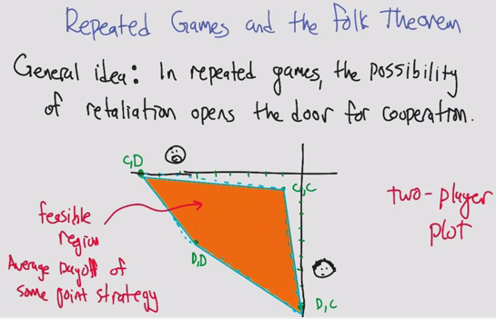

Minmax Profile

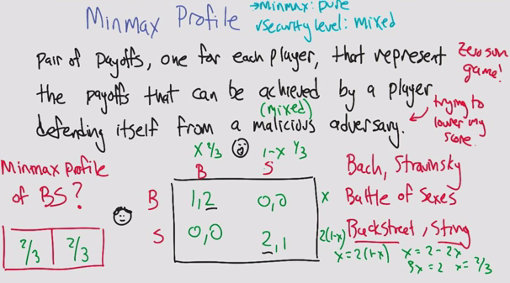

* Agent 1 and 2 deciding to go to Bach/Stravinsky
  + Example also works for Backstreet Boys and Sting
* Minmax Profile
  + Assume malicious AND random adversary: solve it like a zero-sumgame, using x and 1-x
  + MinMax Profile:
    - x = 2*(1-x)
    - 3x = 2
    - x = 2/3
* 1. Minmax strategy, if it is pure, the profile is 1,1
* 2. If mixed, it is 2/3, 2/3

Security level Profile in the IPD (Iterated Prisoner’s Dilemma)

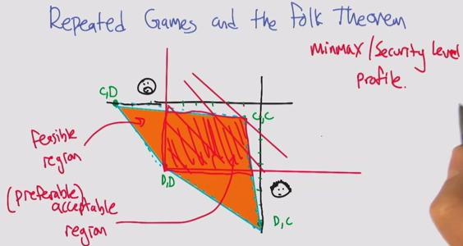

Folk Theorem

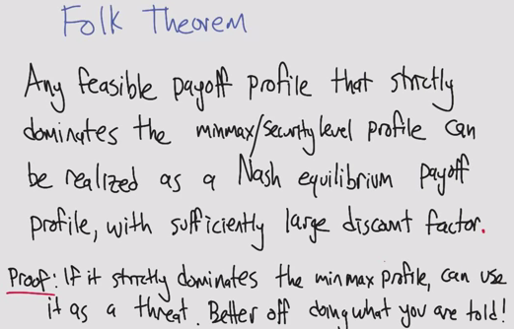

Another IPD Strategy: Grim Trigger

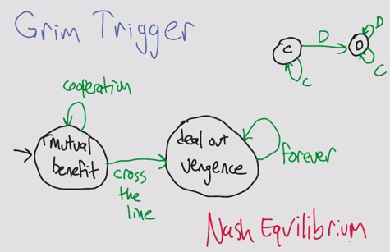

* Added to rational agents, each agent will become vengeful when the other defects
* Can’t do anything better against Grim than to use Grim, therefore Nash!

Implausible Threats

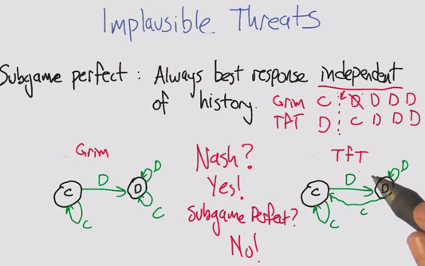

* Assuming that vengeful agents will forgo reward entirely
* Subgame perfect: Always best response independent of history

TfT vs. TfT

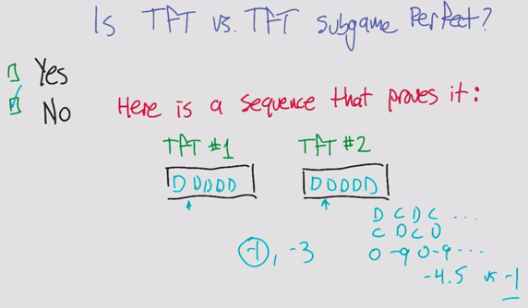

* If you were to change one agent’s actions, could you improve the expected value?

Pavlov

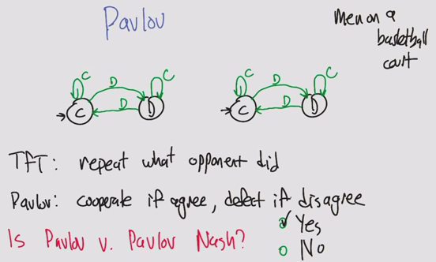

* Pavlov on how animals learn
* Defect against you until you realize it hurts, then cooperate again
* Sort of like men on a basketball court and fouls, aggressive until your opponent is not aggressive
* Pavlov is Nash

Pavlov

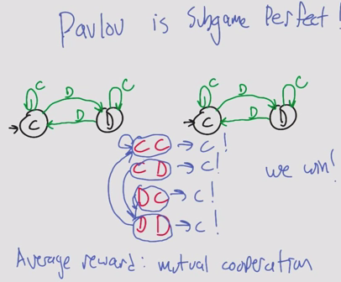

* Pavlov is Subgame Perfect
  + CC gives C
  + DD leads to CC
  + CD and DC lead to DD
  + The result is an average reward of CC
* Why is this interesting?
  + It becomes a plausible threat
  + Even when an agent decides to defect, it turns out the other agent will respond with defect and then the will agree on cooperating again

Computational Folk Theorem

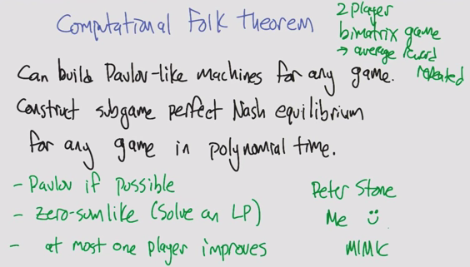

* Assume high discount factor
* Bimatrix if different reward structure per agent

Stochastic Games

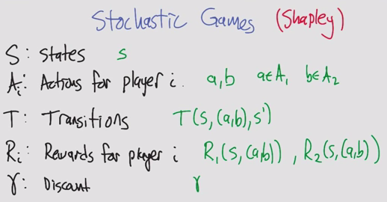

* Sometimes gamma is defined or inherent

Quiz: Match 1/2/3 and A/B/C

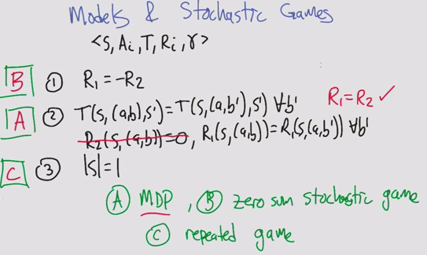

* B: Zero sum: easy
* A: Only one agent: MDP. Rewards only based on agent 1. Rewards of agent 2 don’t matter to agent 1
  + R1 = R2 means the actions agent 1 affect both, but R2 isn’t relevant to agent 1
* C: Only one state, same game. Actions affect rewards but not transitions

Zero sum stochastic games

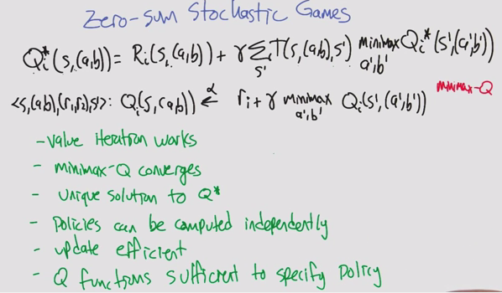

* Zero-sum game assumes 2 players. 3 players is general sum with one player to make the sum 0
* Use minimax Q (max Q for a’ b’ does not make sense, since it is zero sum)
* Minimax can be solved using a linear program
* It’s like a 1 agent game, but now with 2

General sum stochastic games

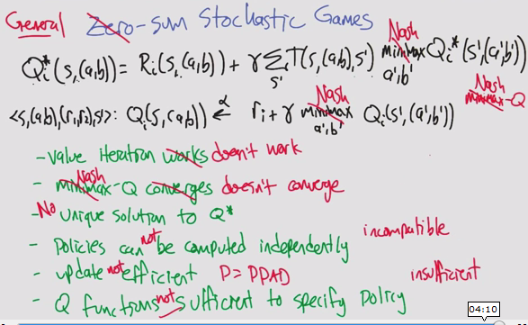

* Minimax doesn’t work with 3+ players
  + Replace with Nash
  + PPAD, as hard as NP for computation time
* Many many difficulties

Lots of ideas

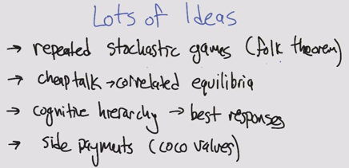

* Coco: cooperative competitive values

Summary

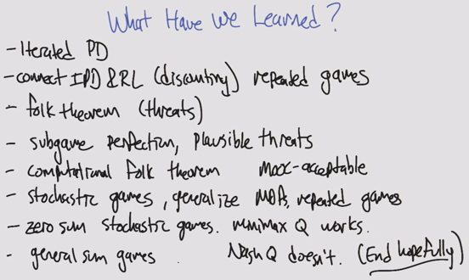

# Extracurricular Learning

* O notation
  + <http://cglab.ca/~morin/teaching/2402/notes/bigoh.pdf>
  + O(g(n)) is a set of functions that contains f(n)
* Eigenproblems
* Math of policies, converging
* Andrew Moore

# ML Terminology

* Monotonic: One direction
* Non-Increasing: Equal or smaller
* Clustering: Richness, Scale-Invariance, Consistency
* Mutually Contradictory
* Strongly/weakly relevant & irrelevant have to do with ***information***
  + If removed, how does it impact Bayesian Optimal Classifier?
* Usefulness has to do with ***error***
* Polysemy: word has multiple meanings. False positives
* Synonymy: same meaning expressed in different words. False negatives
* Mutual information: are the inputs similar?
* Entropy: does the feature have any information?
* Markovian: Only present matters
* State
* Action
* Transition
* Reward: Immediate
* Utility: Sum of discounted rewards of a policy (longterm)
* Maximin
* Minimax
* Components of a game: # players, finite, game sum, deterministic/probabilistic, perfect/imperfect/hidden info
* Normal agent: assumes it is trying to maximize, behaves rationally
* Strategy: pure/impure
* Nash’s Equilibrium: A game where each agent will not change its strategy as long as all other agents do not either
  + No profitable deviation
* Folk Theorem in Game Theory
* Malicious adversary: All you care about is hurting the opponent
* Minmax profile: Expected pairs of payoffs
* Security profile: Feasible region > Acceptable Region
* Grim Trigger: Strategy of cooperating but becoming vengeful when wronged
* Subgame Perfect: Optimal strategy is independent of history
* Pavlov: Strategy of cooperating when the same, defecting when different

# Piazza

* Romeo
  + **Let's update this post adding resources to help us prep for the final exam.**
  + There are no transcripts/slides for this section of the course, but I found these screencaps and notes by Qing Yang: Thanks, wherever you are!

* + Clustering: <http://www.jianshu.com/p/dd26d36cc465>
  + Feature Selection: <http://www.jianshu.com/p/87fbe8378873>
  + Feature Transformation: <http://www.jianshu.com/p/530c4aeac948>
  + MDPs: <http://www.jianshu.com/p/881ab7e41adb>
  + Reinforcement Learning: <http://www.jianshu.com/p/5134962f78ee>
  + Game Theory: <http://www.jianshu.com/p/e294d3f5237c>
  + Game Theory II: <http://www.jianshu.com/p/ee3f9a553cd2>
  + Other notes and study guides:
  + Ty Abonil's notes: <https://docs.google.com/document/d/1PFTsqUoP5ZrVadmZDBL3IVPM2yRwwV6LwvkSLLbrU1o/edit>
  + From OMSCS's legacy Wiki: <http://gtomscs.org/confluence/display/CS7641ML/CS7641.FA14.+Final+exam+prep>
  + Michael Simpson's: <https://libraries.io/github/mjs2600/ML-Final-Exam-Study-Notes>
  + Dudon Wai's: <https://github.com/dudonwai/dudonwai/blob/gh-pages/docs/CS7641-lectures-screenshots.docx>
  + **Lecture videos to review (all material since midterm):**
  + [Information Theory](https://www.udacity.com/course/viewer#%21/c-ud129/l-672178843) (20m)
  + [Clustering](https://www.udacity.com/course/viewer#%21/c-ud129/l-644878538) (1h 18m)
  + [Feature Selection](https://www.udacity.com/course/viewer#%21/c-ud129/l-627968607) (51m)
  + [Feature Transformation](https://www.udacity.com/course/viewer#%21/c-ud129/l-649069103) (1h 23m)
  + [Markov Decision Processes](https://www.udacity.com/course/viewer#%21/c-ud129/l-684808907/m-651230853) (2 hrs)
  + [Reinforcement Learning](https://www.udacity.com/course/viewer#%21/c-ud129/l-643978935/m-634899040) (57m)
  + [Game Theory](https://www.udacity.com/course/viewer#!/c-ud129/l-668248596) (1h 51m)
  + [Game Theory Continued](https://www.udacity.com/course/viewer#!/c-ud129/l-639748716) (1h 40m)
  + [Outro](https://www.udacity.com/course/viewer#!/c-ud129/l-1571328670) (27m)

# Practice Questions

1. Explain the difference between filtering and wrapping in feature selection.
2. What are the 3 properties of clustering?
3. What is the difference between relevance and usefulness when describing features?
4. What 2 steps does PCA follow?